Stroboscope
# Source: AI Source: Provided by: [Data Path: Persons Table -> ID Column: 1, Name_En Column: Motasem Essam] -> From: [ChatGPT] on [7/17/2026]
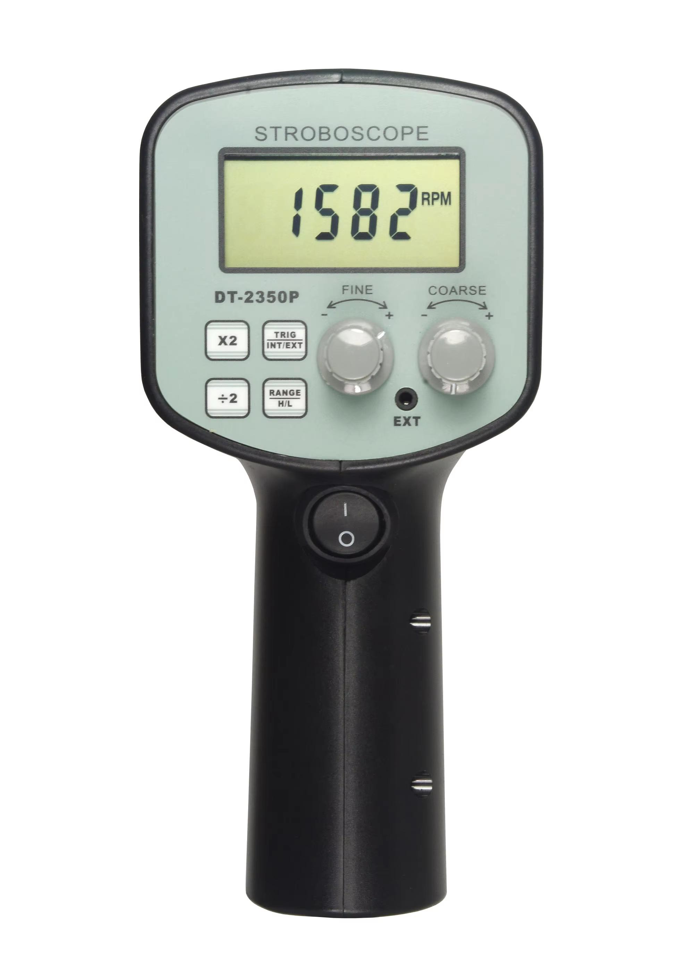
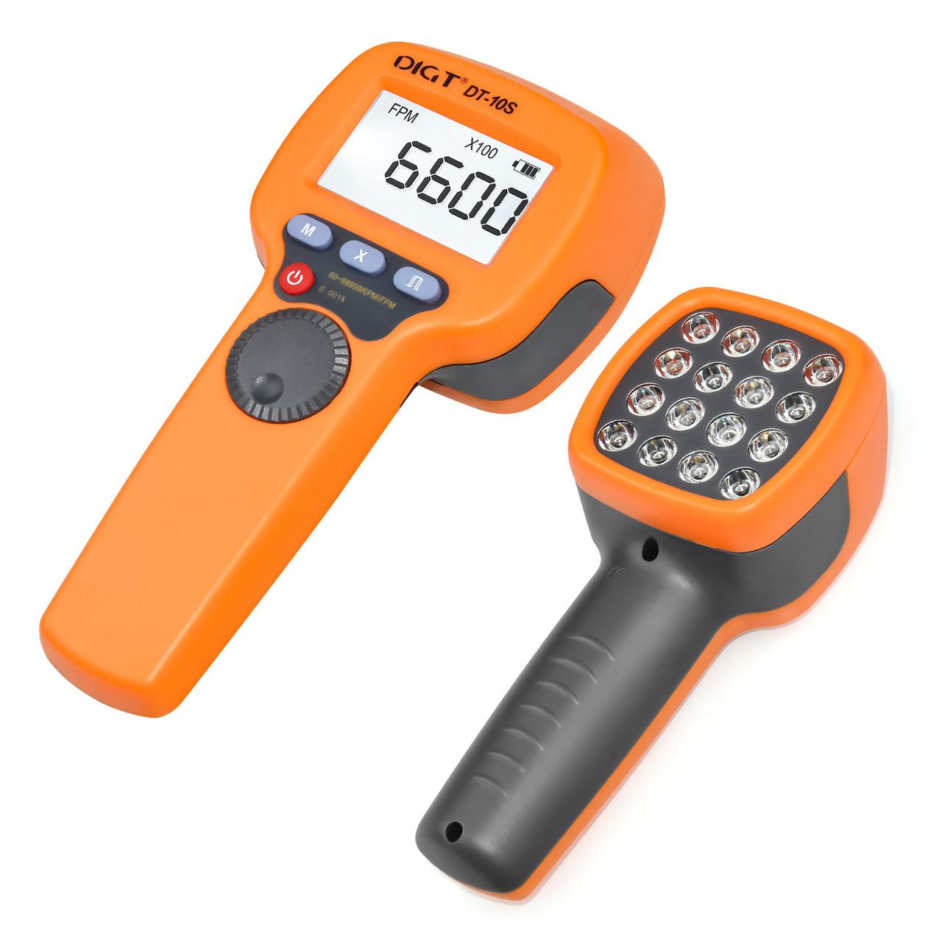
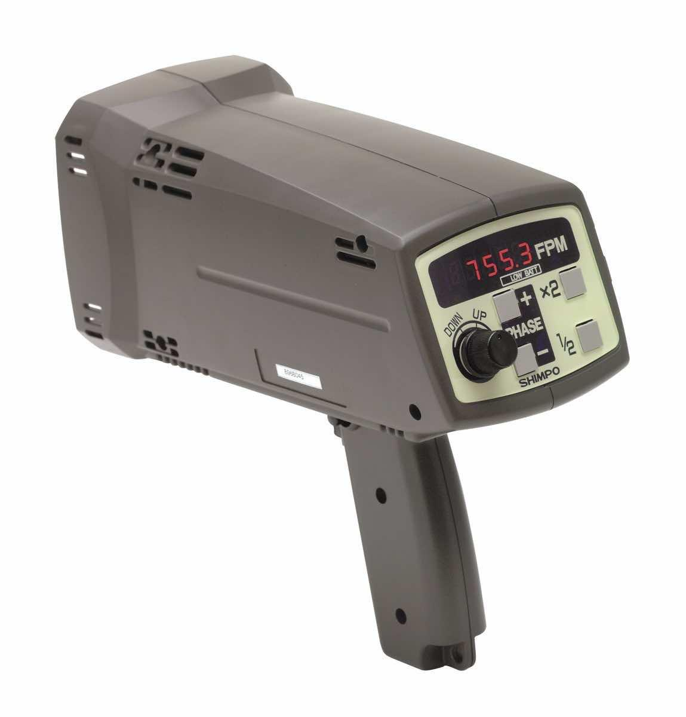
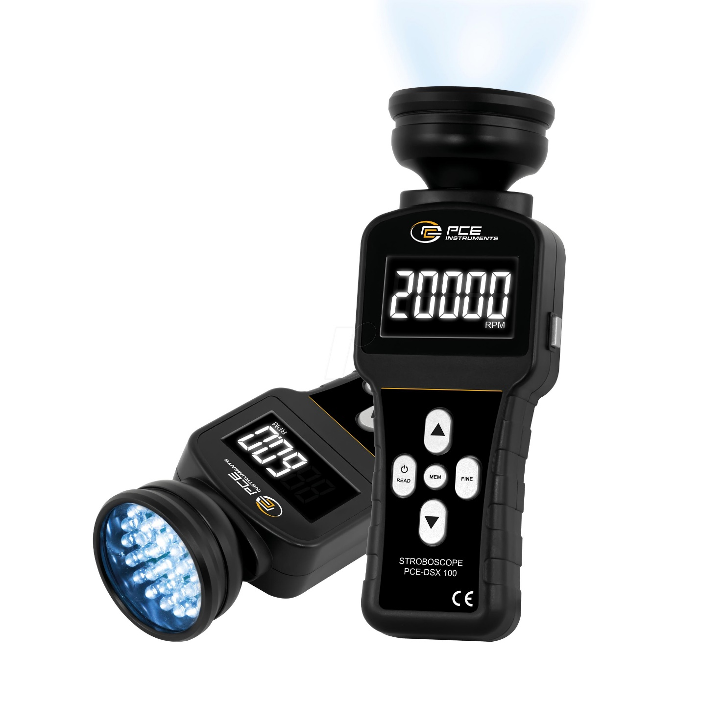
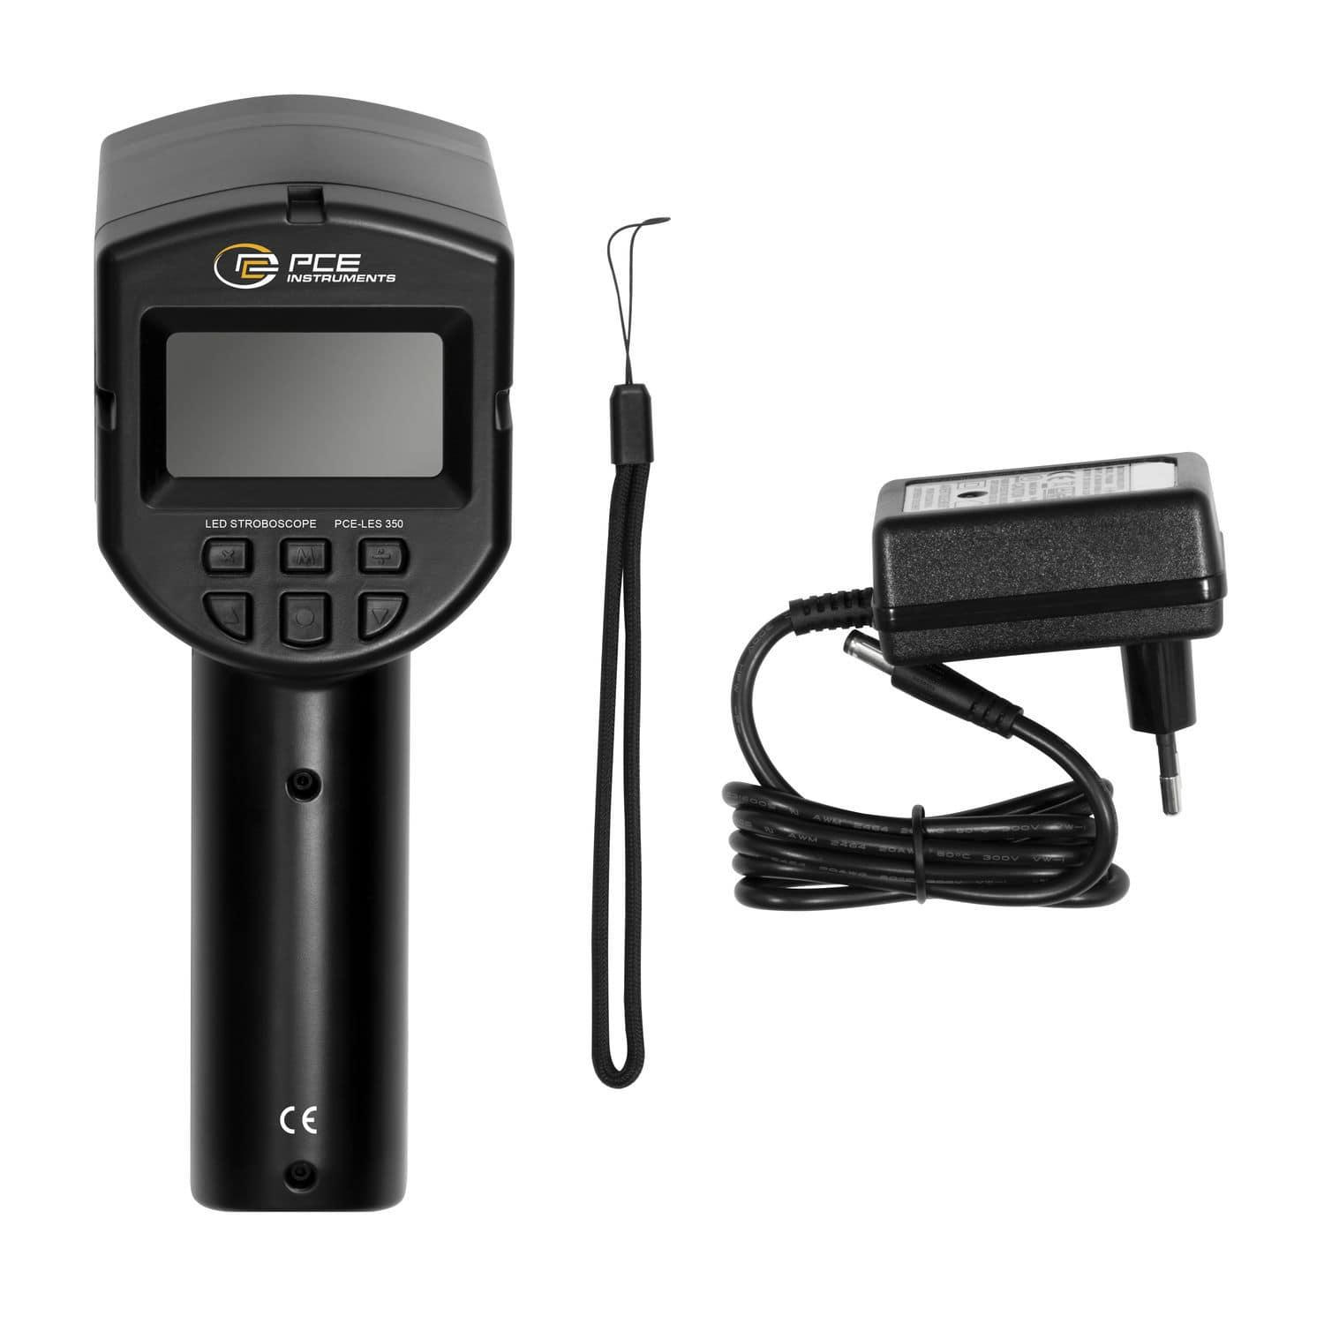
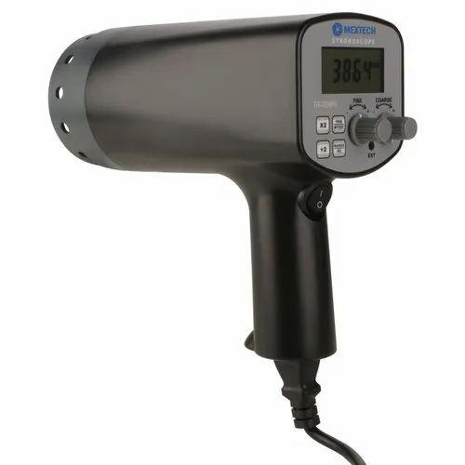
A Stroboscope is an optical measuring instrument that determines the rotational speed or frequency of repetitive motion by emitting flashes of light at an adjustable rate. When the flashing frequency matches the rotational speed of an object, the object appears stationary due to the stroboscopic effect.
Stroboscopes are widely used in industrial maintenance, manufacturing, laboratories, printing, textile production, and machinery diagnostics.

Definition
# Source: AI Source: Provided by: [Data Path: Persons Table -> ID Column: 1, Name_En Column: Motasem Essam] -> From: [ChatGPT] on [7/17/2026]
A Stroboscope is a non-contact optical instrument used to measure the rotational speed (RPM) or frequency of moving objects by synchronizing flashing light with the object's motion.

Purpose
# Source: AI Source: Provided by: [Data Path: Persons Table -> ID Column: 1, Name_En Column: Motasem Essam] -> From: [ChatGPT] on [7/17/2026]
A stroboscope is used to:
- Measure rotational speed (RPM).
- Inspect moving machinery.
- Detect vibration and motion defects.
- Observe repetitive motion.
- Perform non-contact speed measurements.

Principle of Operation
# Source: AI Source: Provided by: [Data Path: Persons Table -> ID Column: 1, Name_En Column: Motasem Essam] -> From: [ChatGPT] on [7/17/2026]
A stroboscope emits rapid flashes of light.
- When the flash frequency equals the object's rotational frequency, the object appears stationary.
- The flash rate is then converted into the rotational speed.

Main Components
# Source: AI Source: Provided by: [Data Path: Persons Table -> ID Column: 1, Name_En Column: Motasem Essam] -> From: [ChatGPT] on [7/17/2026]
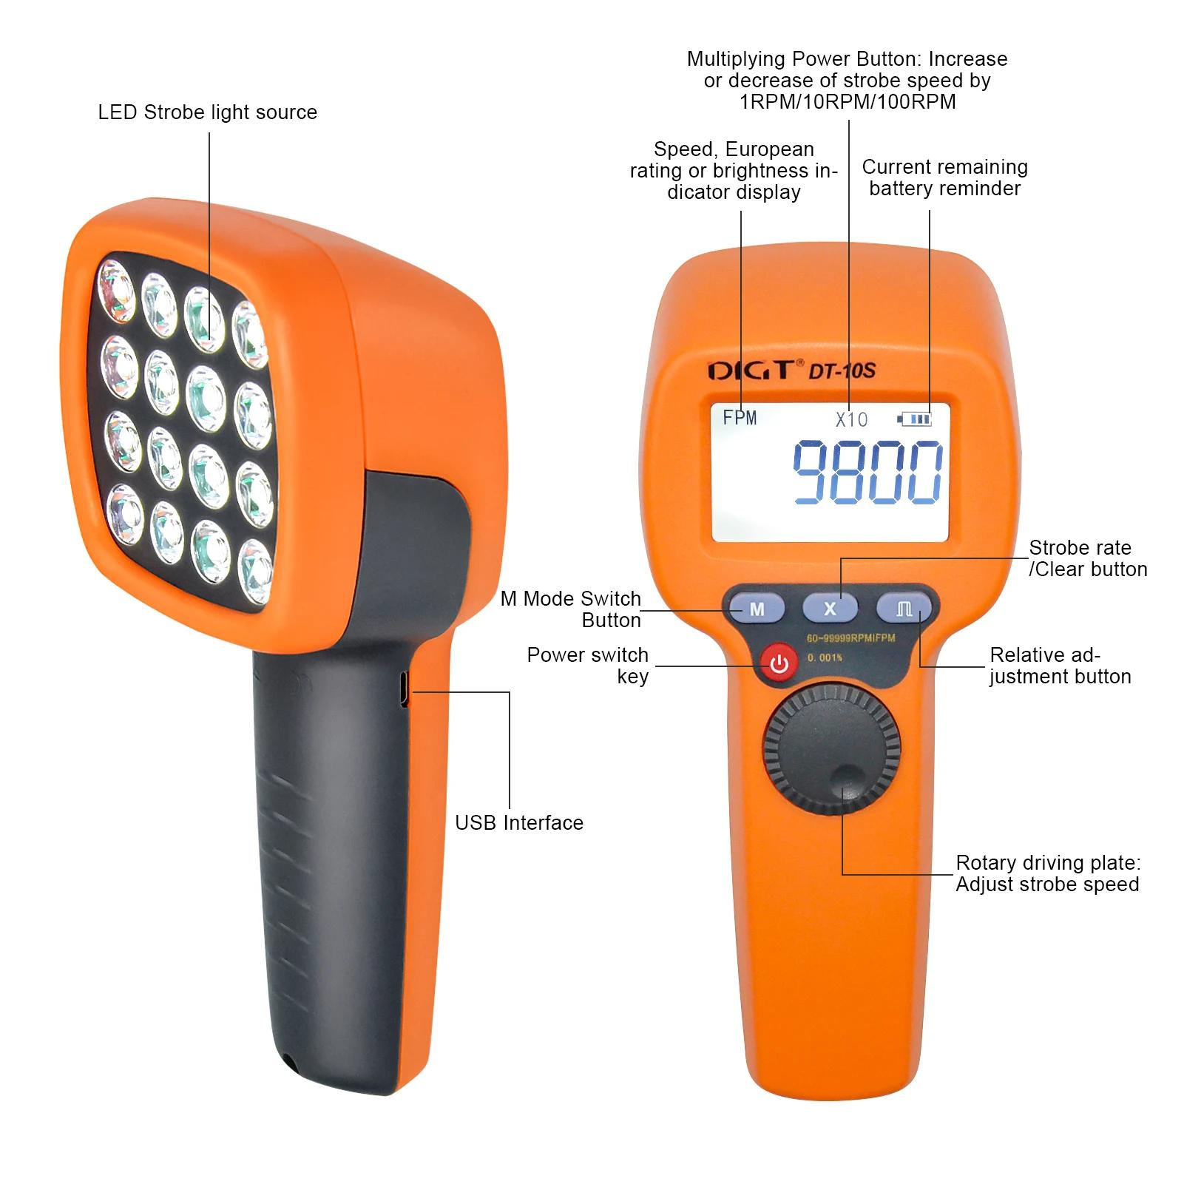
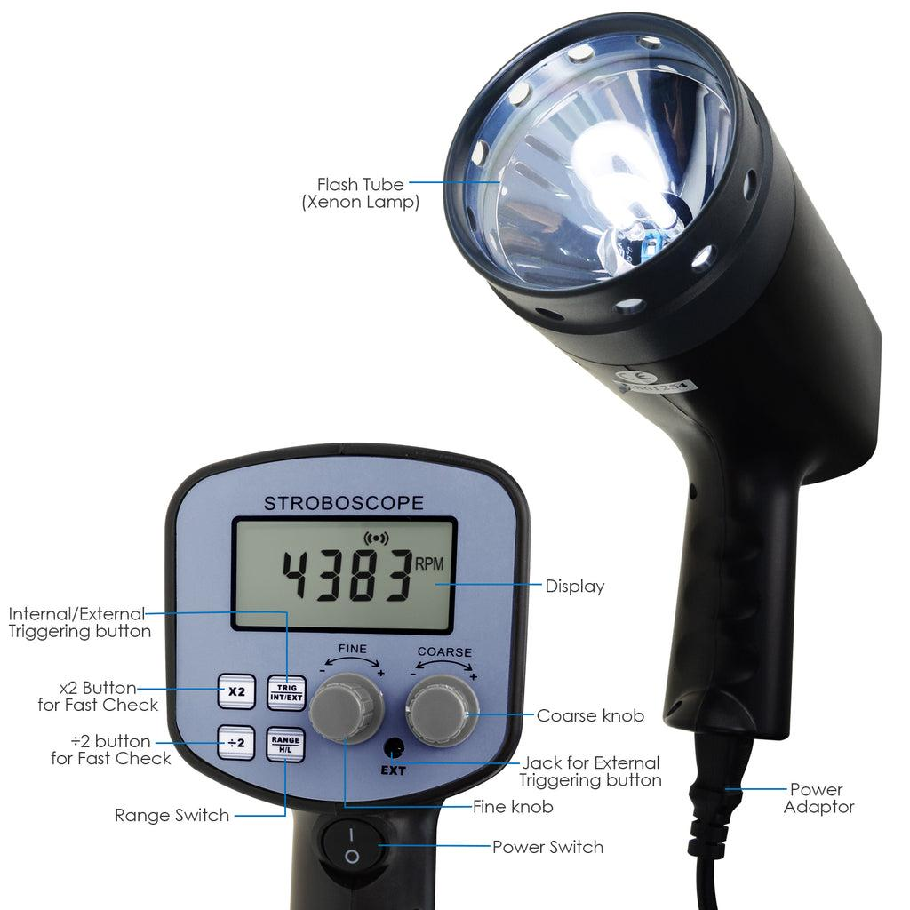
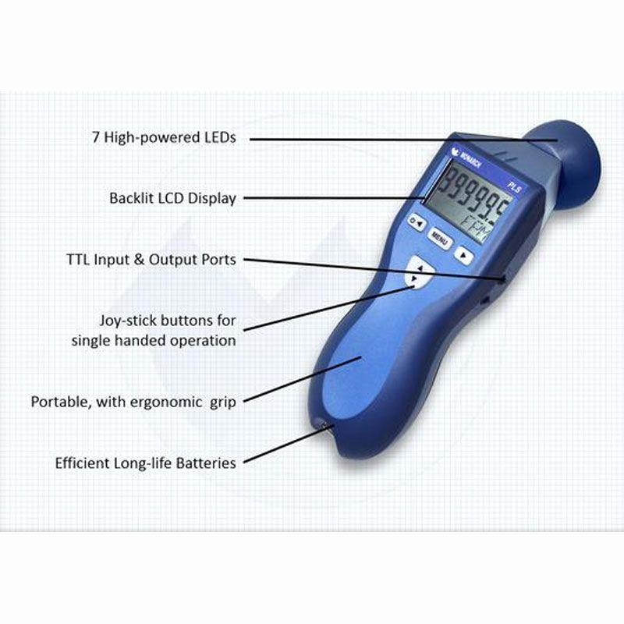
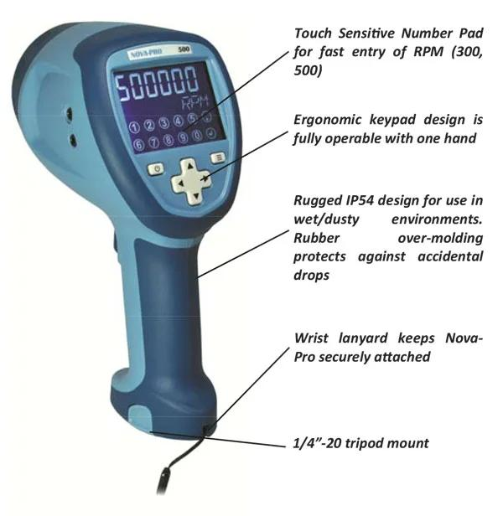
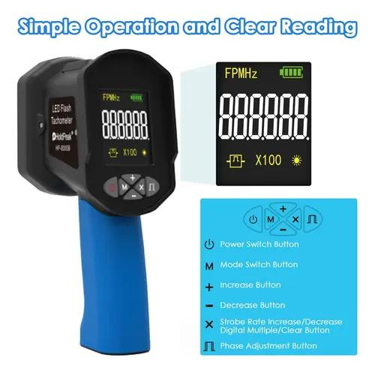
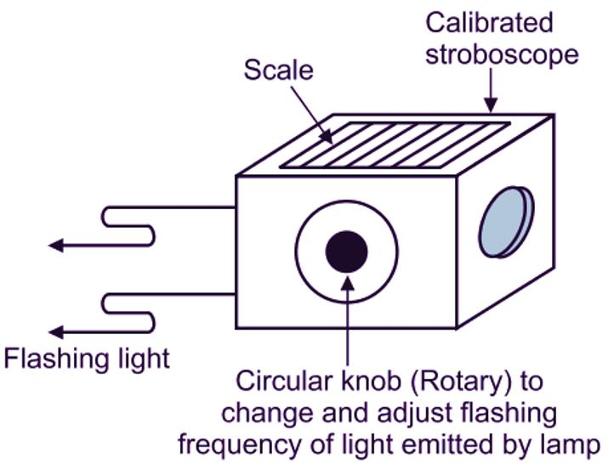
A typical stroboscope consists of:
- High-intensity LED or Xenon flash lamp
- Electronic timing circuit
- Frequency adjustment controls
- Digital display
- Trigger or control buttons
- Battery or power supply

Types of Stroboscopes

1. LED Stroboscope
# Source: AI Source: Provided by: [Data Path: Persons Table -> ID Column: 1, Name_En Column: Motasem Essam] -> From: [ChatGPT] on [7/17/2026]
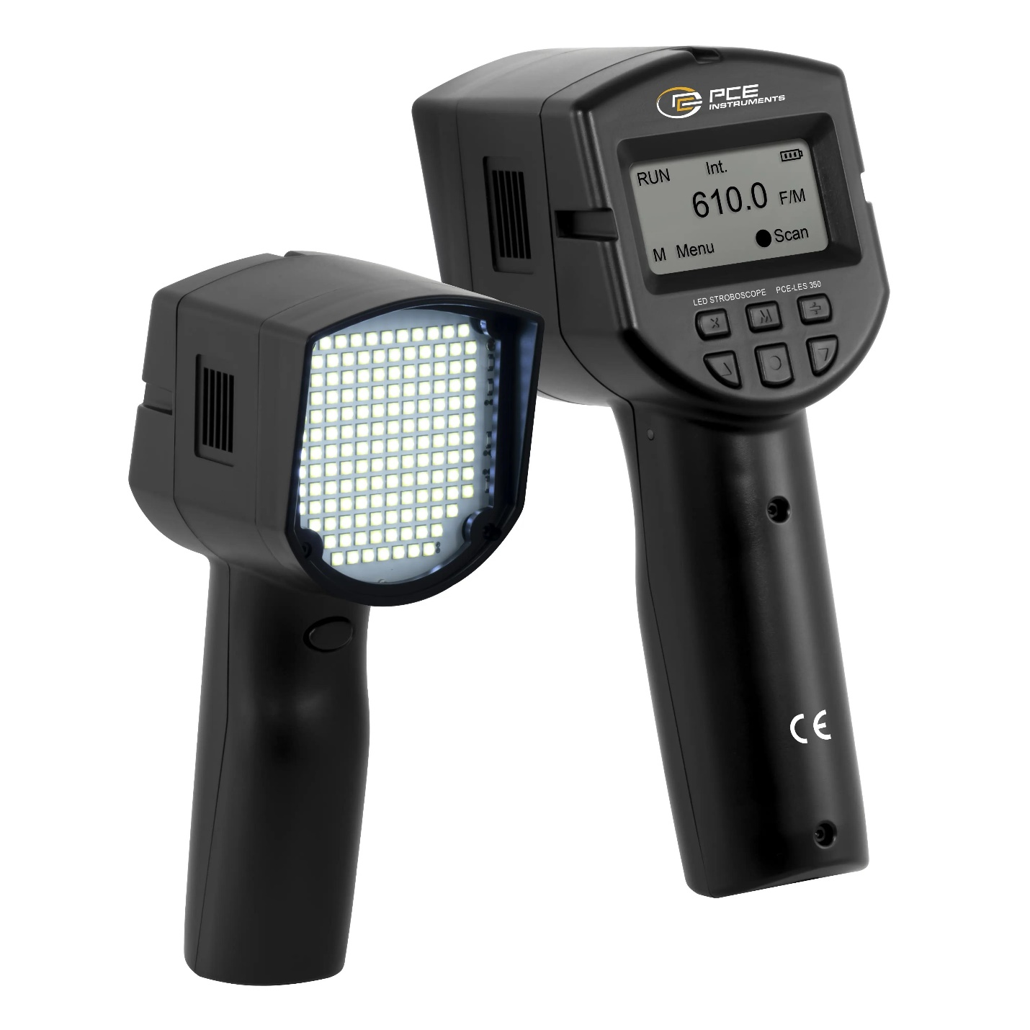
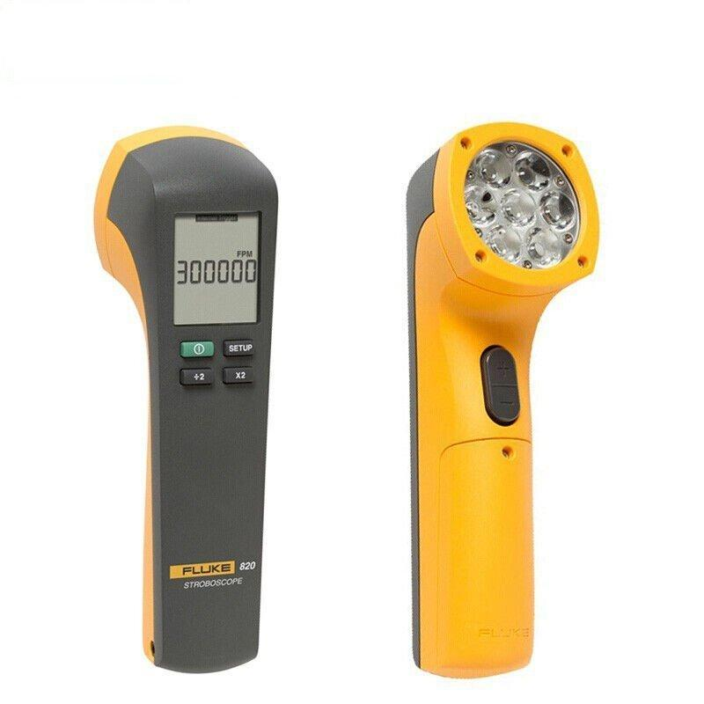
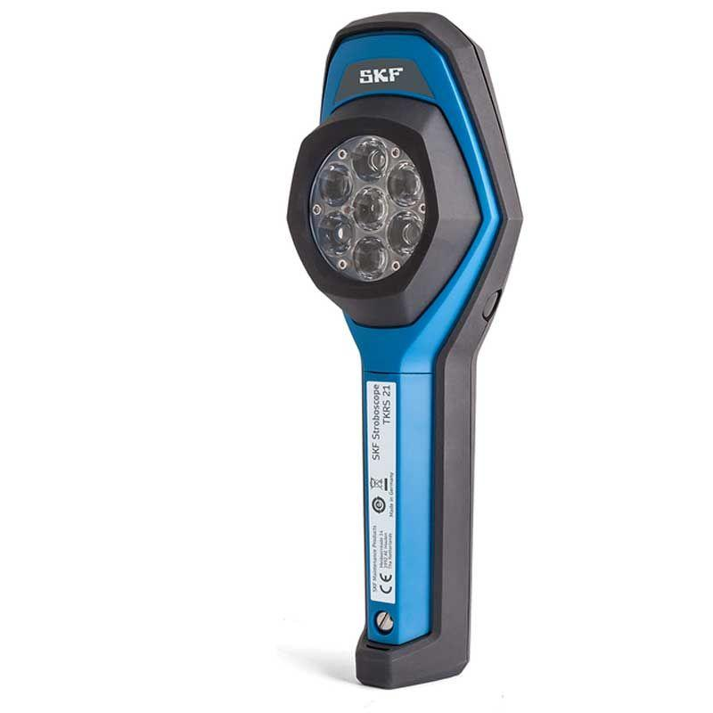
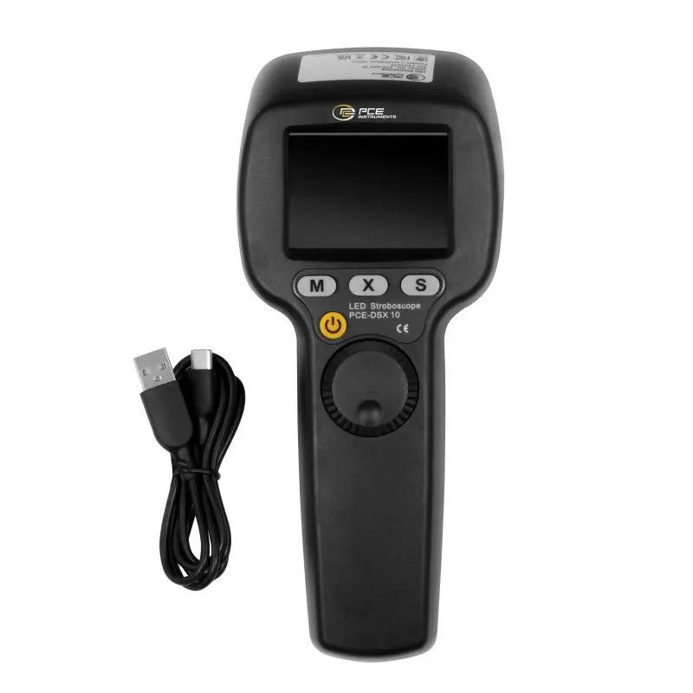
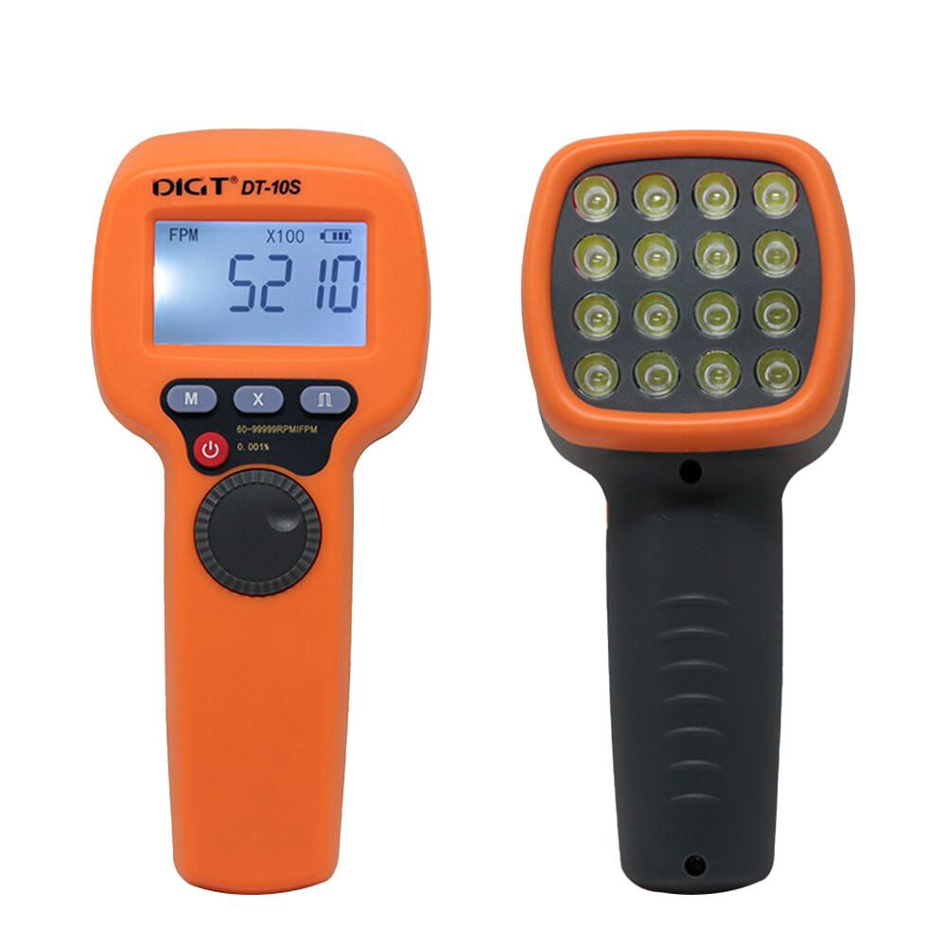
Description
Uses high-brightness LEDs as the light source.
Features
- Long service life
- Low power consumption
- Lightweight
- High reliability
Applications
- Machinery inspection
- Industrial maintenance
- Laboratories

2. Xenon Stroboscope
# Source: AI Source: Provided by: [Data Path: Persons Table -> ID Column: 1, Name_En Column: Motasem Essam] -> From: [ChatGPT] on [7/17/2026]

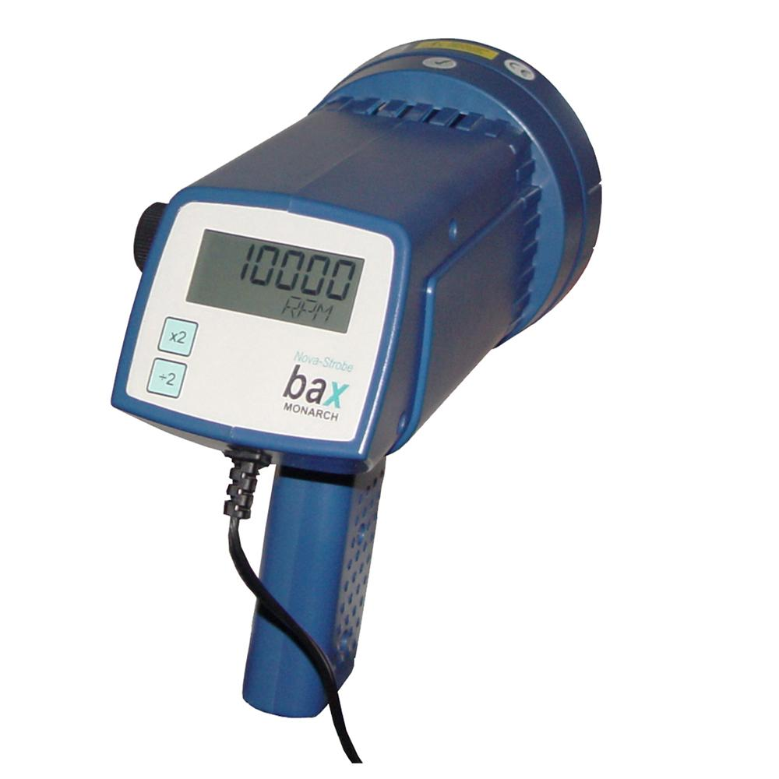
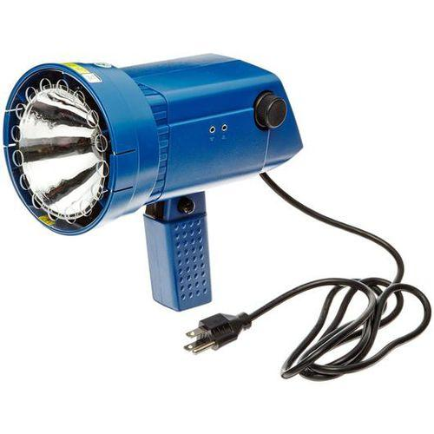
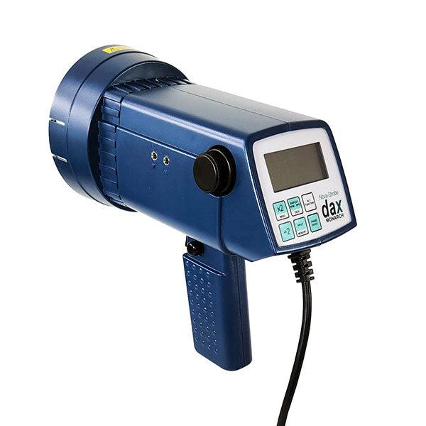
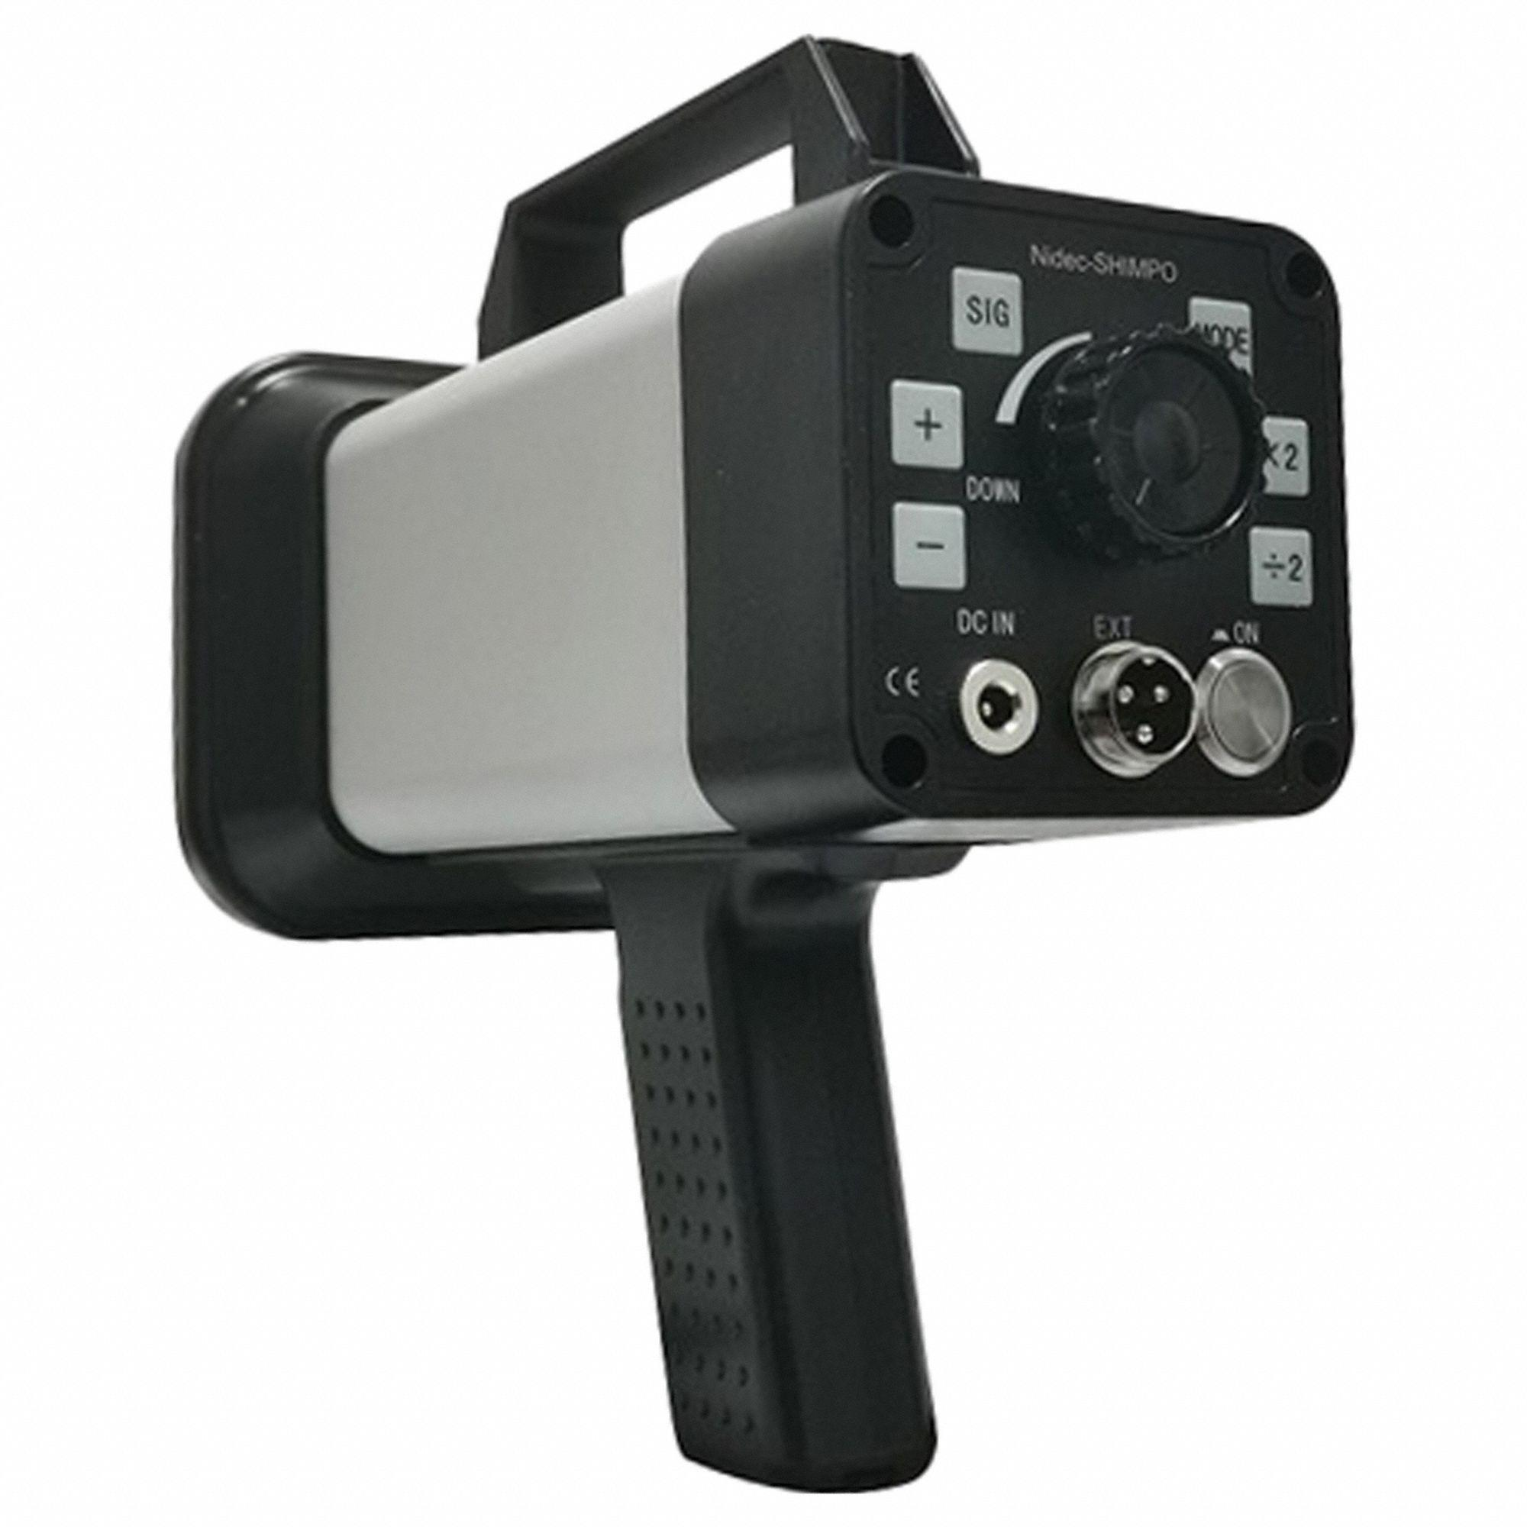
Description
Uses a xenon flash tube to produce very bright light pulses.
Features
- Extremely bright flashes
- Suitable for high-speed applications
Applications
- Printing presses
- Textile machinery
- High-speed rotating equipment

3. Handheld Stroboscope
# Source: AI Source: Provided by: [Data Path: Persons Table -> ID Column: 1, Name_En Column: Motasem Essam] -> From: [ChatGPT] on [7/17/2026]
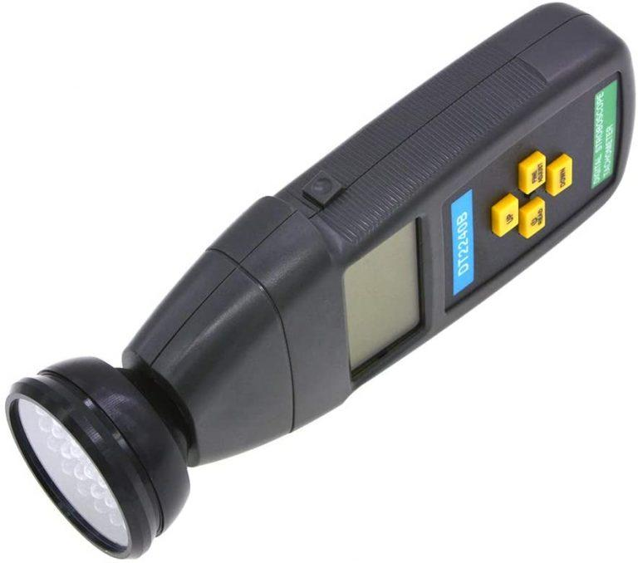
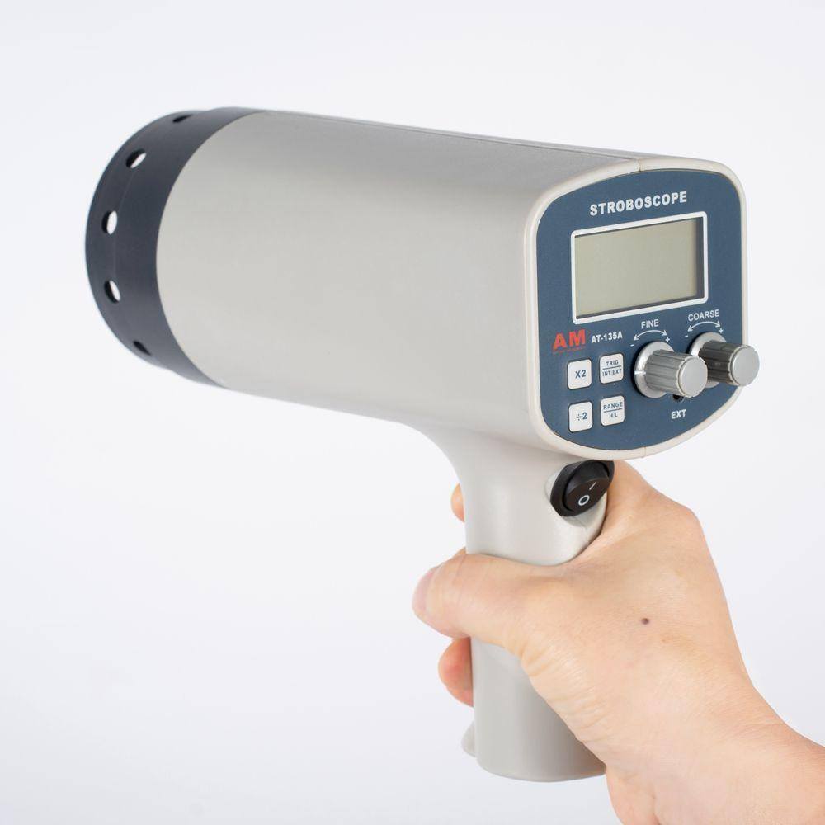
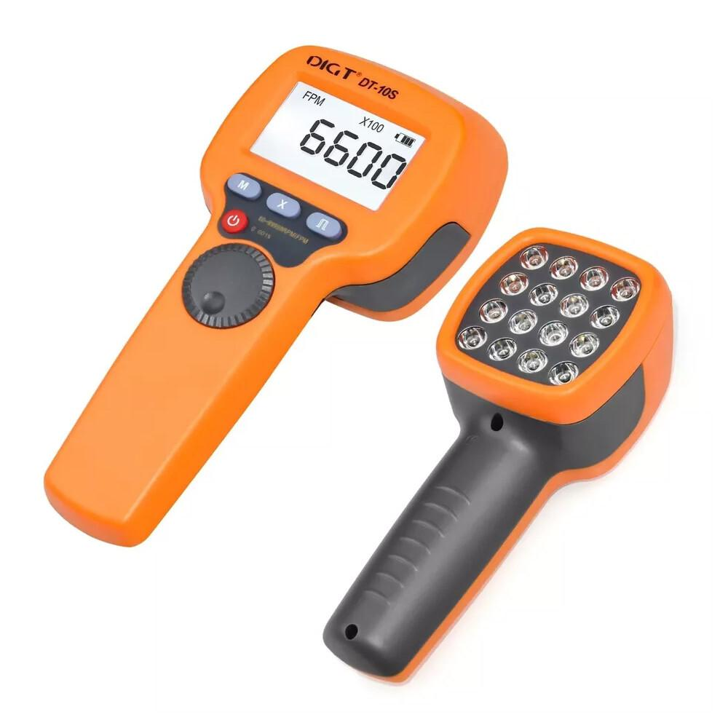


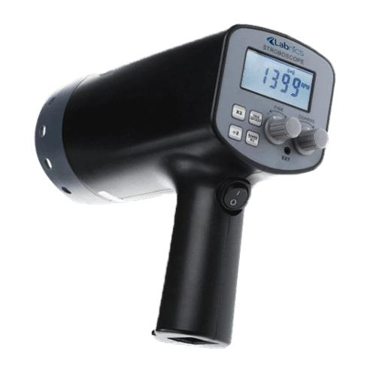
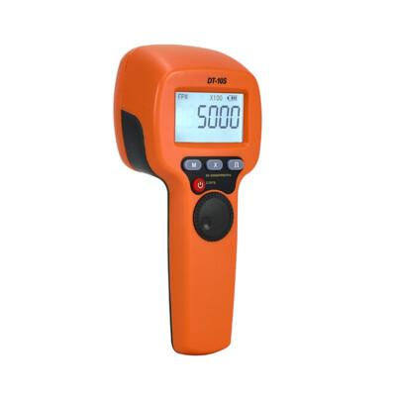
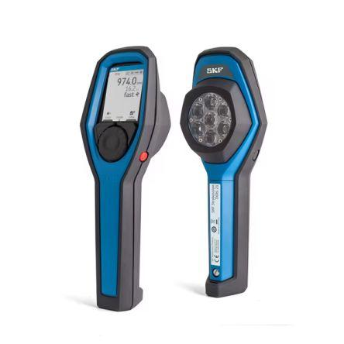
Description
Portable instrument for field measurements.
Applications
- Maintenance
- Equipment diagnostics
- Motor inspection

4. Fixed (Industrial) Stroboscope
# Source: AI Source: Provided by: [Data Path: Persons Table -> ID Column: 1, Name_En Column: Motasem Essam] -> From: [ChatGPT] on [7/17/2026]
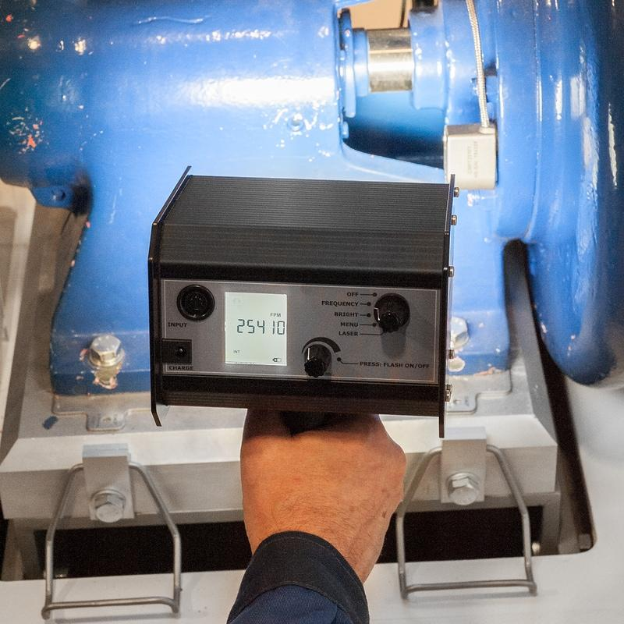
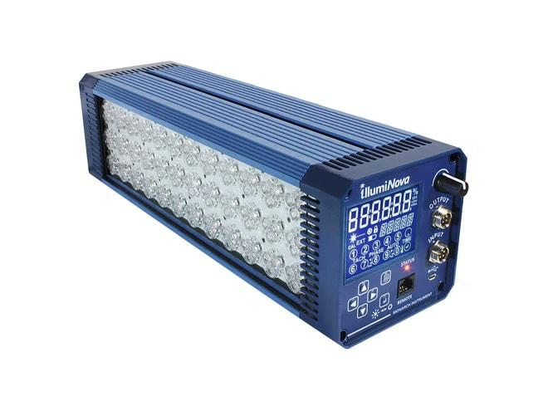
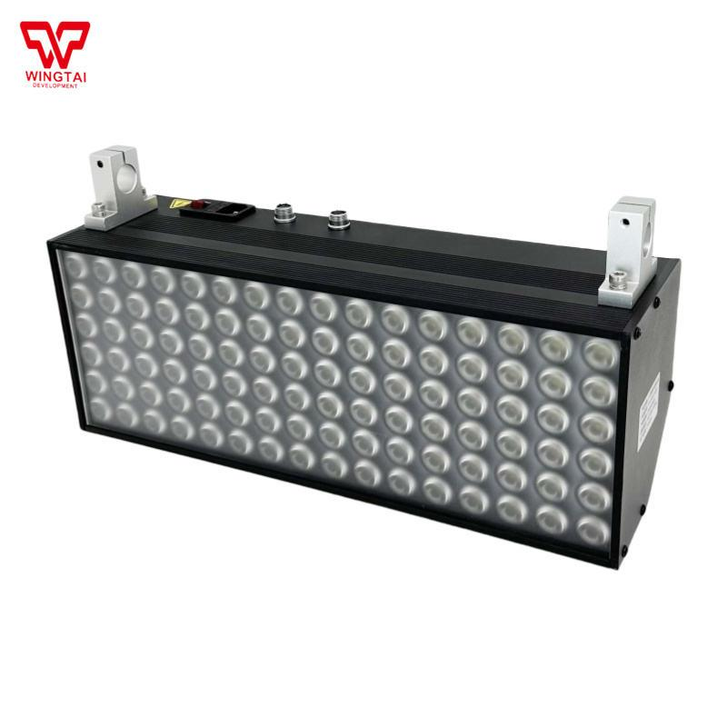
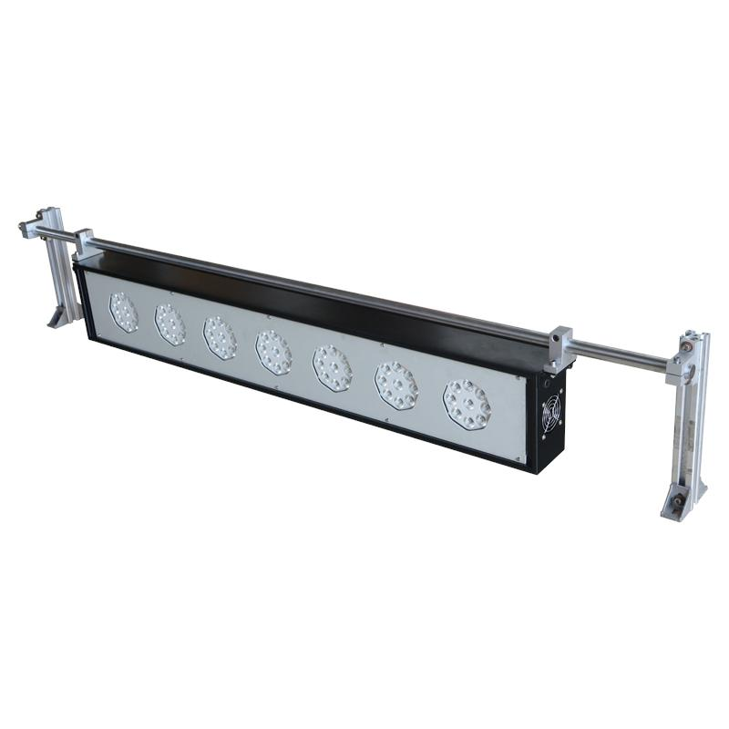
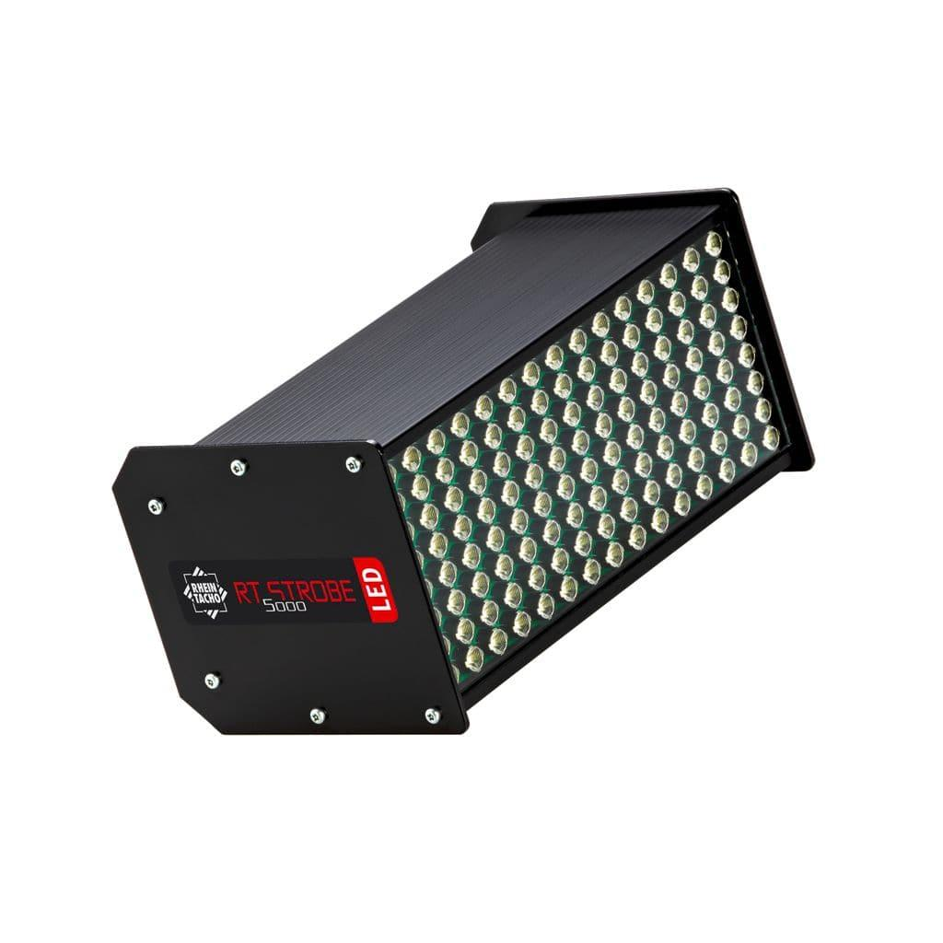
Description
Installed permanently for continuous monitoring of production equipment.
Applications
- Manufacturing
- Production lines
- Industrial automation

Measuring Units
# Source: AI Source: Provided by: [Data Path: Persons Table -> ID Column: 1, Name_En Column: Motasem Essam] -> From: [ChatGPT] on [7/17/2026]
A stroboscope typically displays:
- Revolutions per minute (RPM)
- Flashes per minute (FPM)
- Hertz (Hz)

Measuring Range
# Source: AI Source: Provided by: [Data Path: Persons Table -> ID Column: 1, Name_En Column: Motasem Essam] -> From: [ChatGPT] on [7/17/2026]
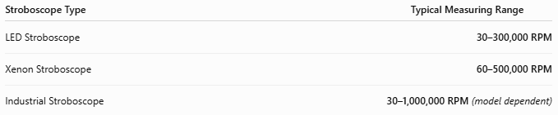
Stroboscope Type | Typical Measuring Range
LED Stroboscope | 30–300,000 RPM
Xenon Stroboscope | 60–500,000 RPM
Industrial Stroboscope | 30–1,000,000 RPM (model dependent)

Resolution
# Source: AI Source: Provided by: [Data Path: Persons Table -> ID Column: 1, Name_En Column: Motasem Essam] -> From: [ChatGPT] on [7/17/2026]
Resolution is the smallest speed increment displayed.
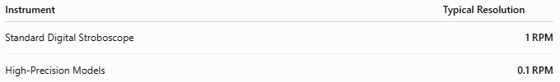
Instrument | Typical Resolution
Standard Digital Stroboscope | 1 RPM
High-Precision Models | 0.1 RPM

Accuracy
# Source: AI Source: Provided by: [Data Path: Persons Table -> ID Column: 1, Name_En Column: Motasem Essam] -> From: [ChatGPT] on [7/17/2026]
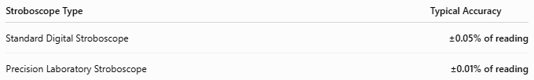
Stroboscope Type | Typical Accuracy
Standard Digital Stroboscope | ±0.05% of reading
Precision Laboratory Stroboscope | ±0.01% of reading
Notes
- Accuracy depends on the stability of the internal timing circuit.
- LED models generally provide very stable flash frequencies.
- Proper synchronization with the moving object is essential.

How to Use a Stroboscope
# Source: AI Source: Provided by: [Data Path: Persons Table -> ID Column: 1, Name_En Column: Motasem Essam] -> From: [ChatGPT] on [7/17/2026]
- Turn on the instrument.
- Aim the flashing light at the rotating object.
- Adjust the flash frequency.
- Continue adjusting until the object appears stationary.
- Read the displayed RPM or flash frequency.

Applications
# Source: AI Source: Provided by: [Data Path: Persons Table -> ID Column: 1, Name_En Column: Motasem Essam] -> From: [ChatGPT] on [7/17/2026]
Stroboscopes are used in:
- Industrial maintenance
- Motor inspection
- Gear inspection
- Printing presses
- Textile manufacturing
- Paper production
- Laboratory experiments
- Research
- Vibration analysis

Advantages
# Source: AI Source: Provided by: [Data Path: Persons Table -> ID Column: 1, Name_En Column: Motasem Essam] -> From: [ChatGPT] on [7/17/2026]
A stroboscope:
- Performs non-contact measurements.
- Measures very high rotational speeds.
- Allows visual inspection while equipment is running.
- Is safe for moving machinery.
- Has high accuracy.

Limitations
# Source: AI Source: Provided by: [Data Path: Persons Table -> ID Column: 1, Name_En Column: Motasem Essam] -> From: [ChatGPT] on [7/17/2026]
A stroboscope:
- Requires a clear line of sight.
- Bright ambient lighting can reduce visibility.
- Incorrect synchronization may produce false stationary images (harmonics).
- Does not measure linear speed directly.

Sources of Error
# Source: AI Source: Provided by: [Data Path: Persons Table -> ID Column: 1, Name_En Column: Motasem Essam] -> From: [ChatGPT] on [7/17/2026]
Instrument Errors
- Timing circuit drift
- Weak battery
- Flash intensity degradation

User Errors
- Incorrect synchronization
- Poor aiming
- Misinterpreting harmonic images

Environmental Errors
- Strong ambient light
- Dust or smoke
- Reflective surfaces

Comparison with Other Speed Measuring Instruments
# Source: AI Source: Provided by: [Data Path: Persons Table -> ID Column: 1, Name_En Column: Motasem Essam] -> From: [ChatGPT] on [7/17/2026]
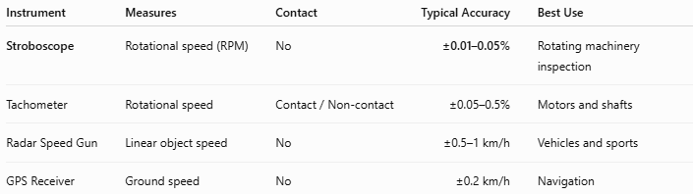
Instrument | Measures | Contact | Typical Accuracy | Best Use
Stroboscope | Rotational speed (RPM) | No | ±0.01–0.05% | Rotating machinery inspection
Tachometer | Rotational speed | Contact / Non-contact | ±0.05–0.5% | Motors and shafts
Radar Speed Gun | Linear object speed | No | ±0.5–1 km/h | Vehicles and sports
GPS Receiver | Ground speed | No | ±0.2 km/h | Navigation

Care and Maintenance
# Source: AI Source: Provided by: [Data Path: Persons Table -> ID Column: 1, Name_En Column: Motasem Essam] -> From: [ChatGPT] on [7/17/2026]
To maintain performance:
- Keep the lens clean.
- Charge or replace batteries regularly.
- Avoid dropping the instrument.
- Store in a protective case.
- Verify calibration periodically.

Common Mistakes
# Source: AI Source: Provided by: [Data Path: Persons Table -> ID Column: 1, Name_En Column: Motasem Essam] -> From: [ChatGPT] on [7/17/2026]
- Using harmonic flash frequencies instead of the true rotational frequency.
- Measuring under very bright lighting.
- Holding the instrument at an incorrect angle.
- Ignoring multiple stationary image effects.

Key Points
# Source: AI Source: Provided by: [Data Path: Persons Table -> ID Column: 1, Name_En Column: Motasem Essam] -> From: [ChatGPT] on [7/17/2026]
- A Stroboscope measures rotational speed (RPM) without touching the object.
- It works using the stroboscopic effect, where synchronized flashes make a rotating object appear stationary.
- Common types:
  - LED Stroboscope
  - Xenon Stroboscope
  - Handheld Stroboscope
  - Fixed Industrial Stroboscope
- Widely used in industrial maintenance, manufacturing, laboratories, and machinery diagnostics.

Conclusion
# Source: AI Source: Provided by: [Data Path: Persons Table -> ID Column: 1, Name_En Column: Motasem Essam] -> From: [ChatGPT] on [7/17/2026]
A Stroboscope is a highly accurate non-contact optical instrument for measuring and inspecting the rotational speed of moving equipment. By synchronizing flashes of light with repetitive motion, it enables technicians to observe rotating machinery as if it were stationary, making it invaluable for industrial maintenance, quality control, mechanical diagnostics, printing, textile production, and scientific research.

